“IMPACT OF PHYSICAL STRUCTURE OF INFORMAL SETTLEMENTS ON THE SOCIAL INTEGRATION OF RESIDENTS"
Sarah Eldefrawi

Paper presented at the International RC21 Conference 2013

Session 01.2
Cluster, neighbourhood, social mix, and networks

Department of Architecture
Housing and Building Research Centre, (HBRC), Egypt
Tahrir Street 87, Dokki, Giza, Egypt
002 012 8 3182734
sarah.defrawy@gmail.com
Abstract

This paper focuses on how social aspects influence the creation of the physical structure of informal settlements and how this pattern consequently impacts the social integration and interaction. The research topic is emerging from the question: why do people choose to live in poorly serviced informal areas rather than the planned served new settlements? Here we try to understand the social aspects in order to answer that question and to discover the relationship between urban physical structure and residents’ social needs. In Egypt, informal settlements emerged in the 60s.Since then, they are continuing to grow according to social factors confined in ‘Familiarization and Proliferation’. Consequently informal settlements physical space is established by the settler social needs that are characterized by compactly close patterns following families’ social correlation and interaction. The result is an environment that is convenient to the settlers’ life style. On the other hand we find that the acceptance of those people to the new sprawled formal settlements that was established from 30 years is very low. This study is seeking to understand the spatial structure of informal settlements by examining the process of their development and the physical patterns of their components with focus on space formation and the order of streets, plots and buildings patterns. In conclusion, this paper establishes a direct relationship between social aspects and physical structure in informal settlements and sheds light on factors that were previously overlooked and should be taken in consideration while planning new towns in Egypt.

Keywords
Informal Settlements, Physical Structure, Social Fabric, Street and plot Patterns, New Settlements
Informal Settlements Phenomena Statement
The phenomenon of Informal settlements has been a continuous mode of urbanization in Egypt since the 60s. For 30 years, there have been many government efforts to limit unplanned growth and urban expansion on agricultural land around Cairo, the capital of Egypt. Despite these efforts, informal settlements continue to grow in most Egyptian cities and villages. These settlements around Cairo have been the home of more than 7 million inhabitants in 1998 (Séjourné, 2006). As of 2006, they are estimated to contain more than 65% of the population of the metropolis area, that is 10.5 out of 16.2 million inhabitants, and the rate of population growth in these areas is higher than other city averages, increasing 2% between 1996 and 2006. (Sims & Séjourné, 2008).
This phenomenon began in the period of Gamal Abdel Nasser when he launched a massive industrialization policy that was concentrated in Cairo. This encouraged the immigration from Upper to Lower Egypt and caused housing demand to become problematic. On the other hand the government didn’t invest in building convenient housing that match that demand and that considers the culture, social and socio-economical aspects of the immigrants. That led to the informal urbanization process on the peripheries, with a substantial increase of rural-urban influx on Cairo. Nasser implemented a cooperative housing policy implemented in Cairo that was also inadequate for creating shelter convenient with low-income families and the large groups of immigrants moving to Cairo. Nasser’s successor, Anwar Sadat, established a new project to create new towns located in the desert areas to absorb those groups. Again, this project offered public housing units convenient to upper middle class and was still not convenient to the low-income families who were the majority of the immigrants. New settlements created by the government since the 60th didn’t achieve till nowadays 50% of the estimated occupancy rate. On the other hand, informal settlements are growing very fast despite the state reinforced legislation forbidding informal construction on agricultural land (Law 59-1966). These laws and decrees were proven to be ineffective and housing demand in informal settlements were and still growing (Abdelhalim 2002).
The first immigrants, who were mostly young men, settled in central or historical districts, where they rented and shared flats or rooms. Later, after amassing some savings, some were able to buy and build upon land on the fringes of the villages located in the peripheral part of the city—such as Kit Kat in Imbaba or Mit Okba in Agouza, both of which are in Giza governorate—where the land market was cheaper than in the central districts. This period also saw the beginning of the phenomena of squatting on state-owned land, mostly in the eastern part of the capital, in places such as Manshiet Nasser and Kum Ghurab in Cairo Governorate. (Séjourné, 2009). The annual growth rate of Greater Cairo attained 4.4% between 1960-1966. This period marks the first expansion phase of informal settlements, mostly on agricultural land in the western (Boulaq al-Dakrour, Waraq al-Hadr, Waraq al-Arab, Munira) and northern (Shubra al-Kheima, Matariya) parts of the city.
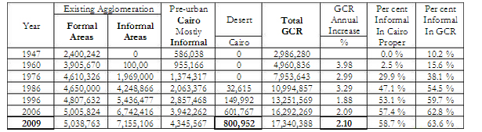
Table 1: Historic Growth of component parts. Source: Sims, 2011
Table1, compare the growth of settlements since the 50th, and it is obvious how fast decline in the formal areas growth rate compared to a very fast growth rate for the informal ones. Here we will mark some social factors influenced the process. Certainly we are not neglecting the financial influence on this process and the high value of the formal real estate market that also helped in the decline. The creation of the physical structure of the informal settlement is a complementary continuous process where social factor influenced shaping the physical structure. Consequently, the features of the built environment impact the social interaction and integration. The social and urban factors are hence complimentary and are dictating the final structure and shape of areas around the city. Some urban planners are looking toward these informally-established physical structures as weak points in the city (Gouda 2013). However, these structures reflect the social needs of the settlers, the connection between their social patterns and the physical structure and how the two elements reflect on each others in the different phases of the settlements.

Urban Socio Morphology
The development of the physical structure of informal settlements follows special patterns, movement, and location of activities that are mainly motivation by the social dimension. On the other hand, when we analyse the physical form including streets, plots and buildings patterns we can extrapolate the direct impact of those elements on social relations.
The morphology of informal areas is based on three phases: Settlement, Familiarization, and Proliferation. The settlement phase started in the 60s when individual young people emigrated from Upper Egypt to the capital. In this phase, the physical structure of the area was still not shaped but there was a continuous subdivision of land with small dimensional plots adapted according the settlers needs. Later on, after the improvement of socio-economic life of the settlers, they began to bring their families and invite relatives to join them in the new location. That’s when the phase of familiarization began. The old settlers helped new ones in finding jobs and buying new locations in the same settlement area. After settling down, those new settlers brought the rest of their families and so on. That’s when the last phase; the proliferation, began. For instance, Manshiet Nasser is a district where people started to settle in 50s to work in the stone quarries on the foot of the Moqattam Mountain. Today, it is the home of 800,000 people. Most of the families living there have are originally immigrants from three areas in Upper Egypt; Qena, Fayyum, and Sohag (Gerlach 2009). Similarly situation exists in other informal settlements in Cairo like the city of dead and Boulaq al-Dakrour.
These phases led to development of physical structure of the place that took its shape according to the type and strength of social relation between the settled groups. The street width and plot patterns are defined according to settler’s needs, interactions and correlation. This is reflecting how much the social dimension influenced development of urban fabric on those areas. Consequently It is interesting to see how the space order in each neighbourhood was different than the other one as it reflects the closeness of families and different patterns of their interactions.
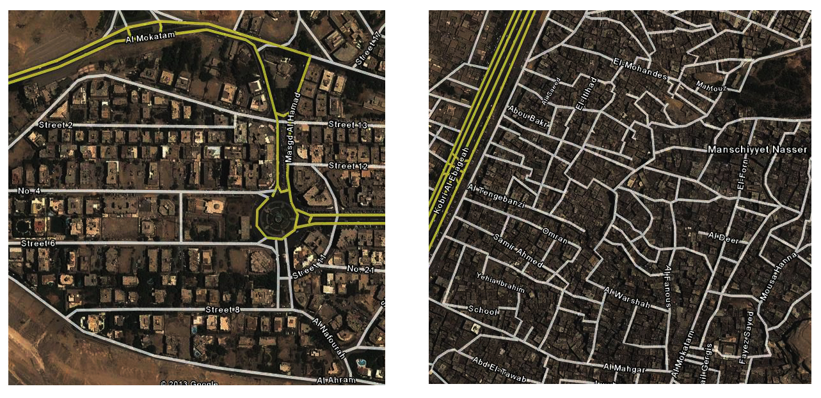
Figure 1: Mokatam and Manshiet Nasser Physical structure (Formal and Informal Settlements) Source: Google Map2013

Figure 1 and 2are illustrating the difference between the urban structure of formal and informal settlement in Cairo in two very close areas to each others; Almokatam and Manshiet Nasser. Both zones are new settlements on desert land that began in the 50s. The Mokatam area was planned by the government. Some lands were sold to citizen according to defined land uses with some construction restrictions; others were built as cooperative housing by the government. Despite the variety of proposed housing market in Mokatam area, Manshiet Nasser was growing much faster. This was a clear indication that formal settlements are not fulfilling the needs of the settlers. The map illustrates how Manshiet Nasser plot division and street patterns is totally different than Mokatam area. Manshiet Nasser was continuously planned during the last 50 years from settlers and developed according to their needs. Consequently a tie fabric is emerging that reflects social and cultural aspects. In Manshiet Nasser, the streets are narrow and some streets are not straight. By survey, we found out that those streets are occupied with one large family. So, these patterns are meant to prevent the penetration of foreigners to these areas. Here we can recognize how settlement is based on the familiarization of zones. Another aspect influenced by the social factor is the names of streets. The streets are mostly named after the name of settlers who are considered as leaders in their corresponding groups.
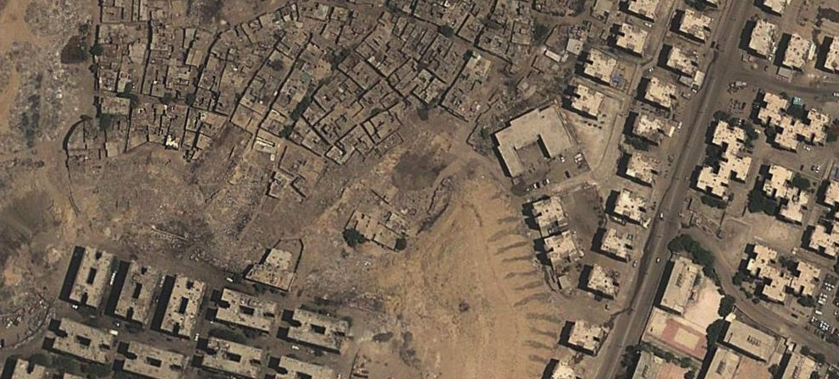
Figure 2: Mokatam and Manshiet Nasser Physical structure (Formal and Informal Settlements) Source: Google Map2013
Shehayeb(2009) also mentioning other factor emphasis that social aspect is important to informal settlement citizens. She mentioned how residents are stressing on the value of the community and helping themselves. Social Solidarity and Community Building, cooperation, social interaction, companionship, and liveliness are all advantages expressed by residents of informal areas.
Socio Economy
From the economical aspect, how the settlements are established in the two phases of ‘Familiarization and Proliferation’ is depending on social dimensions. To create a bulk of money for constructing new dwellings for the new arriving relatives, a social mechanism that is called ‘Gameaia’ is followed. The mechanism is relying on collecting every month from each member in Gameaia fixed number of money. This lasts for one or two years depending on Gameaia members’ number and ends up every month that one of Gameaia members receives the bulk of money. This mechanism of saving money helped new settlers to build up their houses fast and with neighbour collaboration.
This socio economical mechanism is not only used to construct dwellings but also to cover families’ needs for buying anything over their affordance. This mechanism is reinforcing social integration, spreading out trust between residents additionally is contributing in social cohesion due to several visits for money collection.

Street Pattern
Streets in informal settlements are taking many dimensions than just to be a link between two spaces. They work as a social hub. Dwellings orders are emerging as consequent to residents’ social needs that is adding value to the efficiency of street function and giving it support to be the core of activities in the district. Widths of streets are created according to residents’ relations and how much residents want to interact and what kind of activity they want to conducting the street. Consequently streets are created in an efficient pattern to fulfil social and economical aspects. As mentioned before, most residential streets have narrow widths restricting the access of strangers in the area and controlling penetration of traffic. Additionally they allow multiple activities as follows:
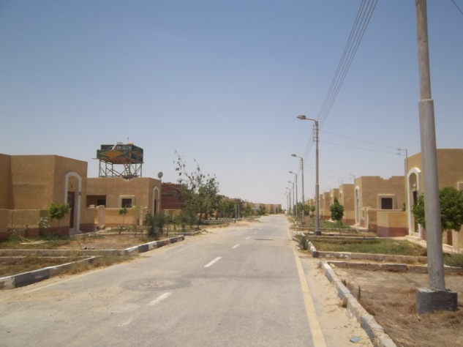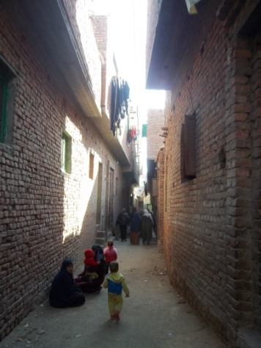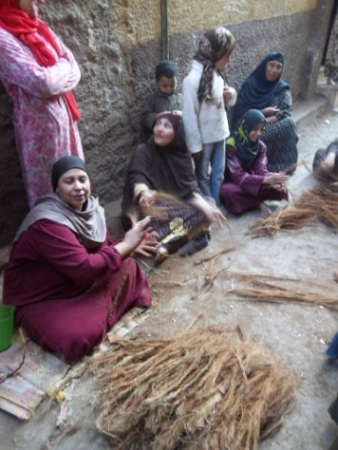
Sprawl Street (Fayoum: remote desert new governemontal settlement 2005, occupancy till now 1%) Photo by Author
Compact Informal Settlements Streets
Photo by Author

Street as Wrokshop
Photo by Author

Street as Extended Home
The street in informal settlements is playing a role as an extension of homes. It plays the role of private, protected place where children can play and women can sit in the afternoon, socialize and exchange news. This appropriation of ‘near home environment’ serves several functions at the same time. First, it compensates for limited private space inside the apartments. More importantly, it also helps building community ties. When neighbours know each other, social solidarity increases, collective initiatives are easier to realize, and natural surveillance and self-policing occurs (Shehayeb 2009).
Street as Extended Work Space
Street activities are not only limited to interactions between neighbours but also play important role as an economical activity space. Especially for women, the parts of the street in front of their houses are used as workshops for handmade crafts and a market for selling fresh fruits and vegetables. Streets are also places for food stands including fast food and authentic Egyptian dishes such as Foul, Falafel and Koshari. This street occupation by the people is giving further potentials. It works as a safety measure as more eyes are on the common spaces and houses, which decreases the crime rate. Furthermore, it is providing a good chance for women to work at the same time while taking care of their household chores. This occupancy also helps social networking and reinforces social relationships.
Street as Extended Cafe
Cafes are part of the streets of informal areas. Chairs are spreading out within a distance that allows only one car to pass by. This is controlling the speed of traffic in the residential districts. Moreover the cafes are located in visually centralized spots where they can be observed from all the surrounded dwellings. The cafe is an observing space besides being an entertainment spot. It is considered a special social activity place where husbands can enjoy time with friends after work under the supervision of wives. Additionally, the easily accessible location connects husbands with their homes and any needs by their families during their leisure time. Hence, the locations of cafes close to homes offer a feeling of security for families.
Street as Extended Ceremony Hall
Ceremonies such as weddings, religious festivals and even graduations are held in district streets. All families are collaborating in the arrangement of the ceremony. The physical elements of the street and the space play role in the ceremony. Balconies of dwellings are simulating theatre balconies where old family members join event by looking out of their balconies. Decorations (for example multi coloured hanged lighting strips) on the buildings play a role in formulating the ceremony space. All street inhabitants collaborate in the activities of the ceremonies. That’s particularly observed in marriage ceremonies, as all district families are helping in carrying new household elements, arranging missing elements for couples and even collecting money to bring present for married couples according to their priority needs.
Street as Extended Playground
The street in informal settlements serves also as a playground for children. It provides a secure and safe environment due to its proximity to their houses. The width of the street helps the children to deal with the space as playground where they begin to organize it and fix elements that reflect certain functions in their games. This integration between the children and the street have influence on the social network in the districts such as creating relationships between mothers of the playing children and generating close network between children and surrounding shop owners. Additionally the occupation of the children of the street makes them as observers of events occurring in the district and spread it out in the area by their mothers.
Plot and Building Pattern
The informal settlements are created with compact pattern and special order that is respecting the proximity of services, work and home. The distribution of such uses is not chaotic. They are usually situated on location according to aspects such as considering the penetration into the narrower residential streets, which consequently remain protected from strangers. Distances between the three elements: work, services and homes are usually kept within walking distance. These patterns can be observed in many areas, such as Boulaq al-Dakrour, where 60% of residents go to work on foot. Walking is the most often utilized means of transportation in informal areas. The compactness of the built forms, and the presence of commercial pedestrian streets tied to residential streets without interruptions by wide vehicular traffic routes, is major factors. (Shehayeb 2009). Action of walking everyday has also a social dimension. It creates eye connection between pedestrians and other residents (sellers, cafe visitors...etc). The distribution of shops and markets in informal settlement in proximity with residential plots fulfil the needs of the residents and are easily accessible. In addition, another social dimension can be observed in shops owners’ behaviour toward residents. They present the goods to the residents at affordable prices and consequently that reinforces the relationship between them.
As for public services, they depend heavily on residents’ participation. They are playing a main role performing tasks such as garbage collection, street lighting, street cleaning, and public landscaping. These elements are performed quite successfully in residential streets, where narrow widths restrict the access by strangers and can be only be controlled by their residents. Shehayeb is mentioning that people clean and maintain what they feel is theirs. It is found that resident participation is limited in areas where these tasks are considered to be governmental responsibilities. Main streets, for example, are not maintained by residents as those streets are more public, shared by many, open to outsiders, and hard for residents to control. As a result, it is common to find piles of garbage, inadequate street lighting, and poor pavement conditions in these public areas.
Physical Structure of Informal Settlements versus New Towns
The previously mentioned characteristics of the informal settlements fulfil social aspects of immigrant residents better than newly planned towns. The new towns residency rate in Egypt didn’t exceed more than 50% of the target occupancy rate (GOPP). The social implications of the informal design, as discussed before, are an important reason that people prefer living in these informal areas despite their poor conditions compared to planned new towns. The planned towns are based on sprawl design were street, plot and building patterns may serve functional needs but are overlooking the social needs of residents. For example, the residential streets width in the new cities in Egypt such as the 6th October city and Sheikh Zayed city are up to 45m compared in those in informal areas that don’t exceed 6m. These large streets affect the level of socialization between the residents and preventing the formation of strong community ties. That large streets design also opens the door for troublemakers to infiltrate the neighbourhood. That makes the informal settlements a safer environment. This can be seen the free movement of women and children in their districts and the fact that they often leave their doors and windows unlocked. Also, as mentioned before, commercial uses, workshops, ceremonies, cafes and children playgrounds are factors that make the place much safer compared to new towns where distances are very wide and hence some places may be left unwatched.
Informal settlements that emerged from community needs should be re-evaluated to understand the priorities and considerations upon which residential choices are based. These considerations can then reflected in the planning and design in the new settlements to ensure that the design is appealing to these residents. The above potentials in informal settlements can be summarized as a lack of attention of the government toward people social needs and cultural aspects. The social aspect in particular is currently overlooked by the government while designing new towns which eventually leads to residents leaving these towns and building their own communities elsewhere.

References
- Abdelhalim, K. (2002). An alternative approach for housing the urban poor in Egypt: Prospects and constraints. PhD Thesis, University of Central England in Birmingham.
- Bayat, A., & Denis, E. (2000). Who is afraid of ‘ashwa’iyyat?: Urban change and politics in Egypt. In Environment and Urbanization, 12(2), 185-199.
- Denis, E. (1996). Urban planning and growth in Cairo. Middle East Report, 202, 7-12.
- Denis, E., & Sejourne, M. (2002). ISIS: Information system for informal settlements. Cairo: Ministry of Planning, GTZ, CEDEJ.
- Dorman, J. W. (2007): The politics of neglect: The Egyptian state in Cairo, 1974-98. PhD Thesis. School of Oriental and African Studies, University of London.
- El Batran, M., & Arandel, C. (1998). A shelter of their own: Informal settlement expansion in greater Cairo and government responses. In Environment and Urbanization, 10(1), 217-232.
- El Kadi, G. (1987a). L’Articulation de deux circuits de gestion foncière au Caire. In Peuples Méditerranéens.
- El Kadi, G. (1987b). L’Urbanisation spontanée au Caire. Fascicule de Recherche.
- General Organisation for Physical Planning (GOPP), Ministry of Housing, Utilities and Urban Communities (1998).
- Gerlach, J. (2009) GTZ report “Cairo’s Informal Areas between Urban Challenges and Hidden Potentials.”
- Gouda, E. (2013). Urban for rehabilitation of the Informal Settlement in Egypt.
- Madbouly, M. (1998). Urban poverty and informal settlements upgrading: A missing dimension in Egypt. Paper presented at the Association of Graduates and Trainees from Britain in Egypt’s Seminar on Cities, Capacities and Development, 23 November, 1998.
- Séjourné, M. (2006). Les politiques récentes de “traitement” des quartiers illégaux au Caire. PhD Thesis, Université de Tours, France.
- Sims, D., & Séjourné, M. (2008). The dynamics of peri-urban areas around greater Cairo: A preliminary reconnaissance. Washington, D.C.: World Bank.
- Sims, D., & Séjourné, M. (2000). Residential informality in greater Cairo: Typologies, representative areas, quantification, valuation and causal factors.
- Shehayeb D. (2009). GTZ report “Cairo’s Informal Areas between Urban Challenges and Hidden Potentials.”
- Signoles, P. (1999). Acteurs publics et acteurs privés dans le développement des villes du monde arabe. In P. Signoles, G. El Kadi, & S. R. Boumedine (Eds.), L’Urbaine dans le monde arabe: Politiques, instruments et acteurs (pp. 19-53). Paris: CNRS.
- Sims, D. (2000). Residential informality in greater Cairo: Typologies, representative areas, quantification, valuation and causal factors. Cairo: ECES, ILD.
- Sims, D. (2003). The case of Egypt. In UN-HABITAT: Understanding slums: Case studies for the global report on human settlements.

